REGISTRATION FORM OF 14th GCBSS CONFERENCE 2022

28 - 29 December 2022
G Hotel Gurney (5 STAR), Penang, Malaysia
(IN-PERSON & ONLINE)
http://gcbss.org/CIBSSR2022/Registration-Payment.html

14th GCBSS will be held during 28 - 29 December 2022 in G hotel gurney (5 STAR), Penang, Malaysia (In-Person & Online). Please note that it is essential for all participants to email the filled Registration Form (.doc/.docx/pdf) along with Proof of payment receipt to ids: admin@gcbss.org and Cc to register@gatrenterprise.com

SECTION 1: CONTACT INFORMATION
Paper ID Code: For example, CIBSSR-00101
Name that you would like to get printed on the certificate:

Conference Title: 14th Global Conference on Business and Social Science, Penang, Malaysia.
Whether attend the Conference: € Yes € No
Position (Professor/Associate Prof/Assistant Professor/Lecturer/PhD Student/Master Student/other):

Complete Affiliation/Organization/University and Country Name:
(that you like get printed on the certificate)

Broad Field: i.e., Accounting |  | Are you willing to serve as a session chair:€ Yes € No
Session Type:€ Oral Presenter € Poster € 3 Minutes PhD proposal € Visual Presenter (ZOOM)
Telephone: | Mobile: |  | Email:
Special Needs or Dietary Requirements: € Yes €No
Fulltime Student ID Number of Your University (if applicable):
Abstract/Paper Title:
Paper Pages: |  | Additional Page:
Are you interested in joining Conference Tour: € Yes € No
Are you interested in attending the GALA Dinner & Networking: € Yes € No
Are you interested in attending the Workshop: € Yes € No
Are you interested in joining the Academic Discussion Session: € Yes € No

Notes:
- One regular registration can cover a paper within 8 pages, including all figures, tables, and references at 1.5 line spacing. If the length exceeds 8 pages, the authors must pay USD 25.00 for each additional page.

- If the number of authors is more than two in the manuscript, authors must pay additional fees of USD 50 for each different author name.

- For additional Certificates, co-authors need to pay USD 100 for each additional certificate.

SECTION 2: REGISTRATION FEES INFORMATION

14th GCBSS DISCOUNTED FEE STRUCTURE: | Early bird  Until: 25/09/2022 | Normal  Until:  28/10/2022 | Late  Until: 20/12/2022
Oral/Poster Presenter (Lead Author) / Co-author | USD 425 | USD 475 | USD 500
Visual Presenter (Through ZOOM) | USD 325 | USD 375 | USD 400
Full-Time Student (Valid Student ID required) | USD 325 | USD 375 | USD 400
Additional Paper (by the same Presenter) | USD 325 | USD 375 | USD 400
Attendee (Without abstract/Paper) | USD 225 | USD 250 | USD 275
Online Attendee (Without abstract/Paper) (Through ZOOM) | USD 100 | USD 100 | USD 100
Additional Events for 14th GCBSS Delegates:
Academic Discussion Session on 28 December 2022 | FREE | FREE | FREE
GALA Dinner & Networking on 28 December 2022 | FREE | FREE | FREE
Workshop on Publishing in High Impact Factor (SSCI & SCI) Indexed Journals on 29 December 2022 | FREE | FREE | FREE

GATR/GCBSS Policy:

- The lecturer cum student will not be considered for the student rate.
- A full-time student must submit a valid student ID card and letter of recommendation from the Dean.
- Daily Market Conversion Rate applies to all USD prices.
- Service/Transfer Fees are not included in the above prices.

Registration fee of Oral/Poster/ Student Presenter Included:

Admission to the welcome reception and all session

- Academic Discussion Session
- Conference KIT
- Printed presenter certificate with an official seal
- Printed brief program Schedule
- Refereed Abstract Proceeding CD with ISBN
- Journal publication fees (Sponsored by GATR)
- Workshop on Publishing in SSCI & SCI Journals
- Two coffee breaks each day
- International Buffet lunch daily
- GALA Dinner& Networking

Registration fee for Visual/Online Presenter Included:

Admission to the welcome reception and all session

Free Courier of KIT (All Countries)
- Conference KIT
- Printed presenter certificate with an official seal
- Refereed Proceeding CD with ISBN
- Abstract Video publication on Official Channel
- Journal publication fees (Sponsored by GATR)
- Printed program Schedule
- Workshop on Publishing in SSCI & SCI Journals Material & CD
- Best Presenter Certificate

Registration fee of Attendee Included:

Admission to all session

- Participation Certificate with an official seal
- Refereed Proceeding CD with ISBN
- Program Schedule
- Workshop on Publishing in SSCI & SCI Journals Material & CD
- Best Presenter Certificate

SECTION 3: PAYMENT INFORMATION

OPTION 1

Bank Deposit / ATM Transfer / Online Transfer / Telegraphic Transfer in Company official account.

Please Visit: http://gcbss.org/CIBSSR2022/Registration-Payment.html
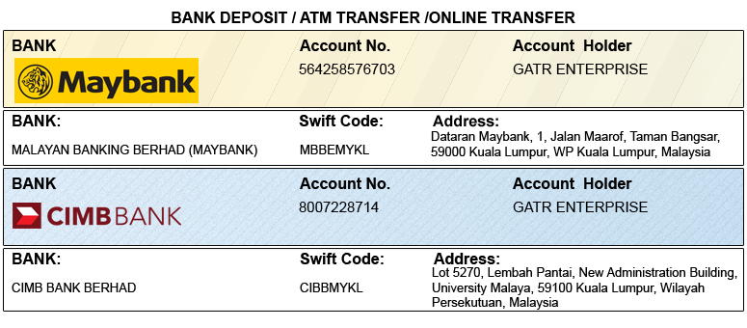

OPTION 2

Credit Card /Debit Card/PayPal/2Checkout Account to GATR 2checkout official account. Registered email: info@gatrenterprise.com

Please visit: http://gcbss.org/CIBSSR2022/Registration-Payment.html
Note: Please mention your Abstract Id in particular to trace your payment. 5% Transaction Charges will be applied for payment through credit card.

PRIVACY POLICY:

The Global Academy of Training & Research (GATR) Division will protect your personal information. Your personal information will only be used to fill your order, and we will not sell or redistribute your information to anyone.

CANCELLATION POLICY:

You may cancel without penalty if a written cancellation request is received up to and including 45 days before the start of the Conference. A credit voucher for less than 50% of the registration fee will be issued for written requests received up to and including 25 days before the start of the Conference. No refunds or credits will be issued on cancellation requests received less than 25 days before the beginning of the event. No liability is assumed by Global Conference on Business and Social Science for changes in program, date, content, speakers, or venue.

PLEASE NOTE: Original receipts will be emailed to register guests before Conference for claim purposes.

Declaration: I agree that I cannot claim back the registration fee I paid under any circumstance.
SIGNED:  (or write name here) |  | DATE:

